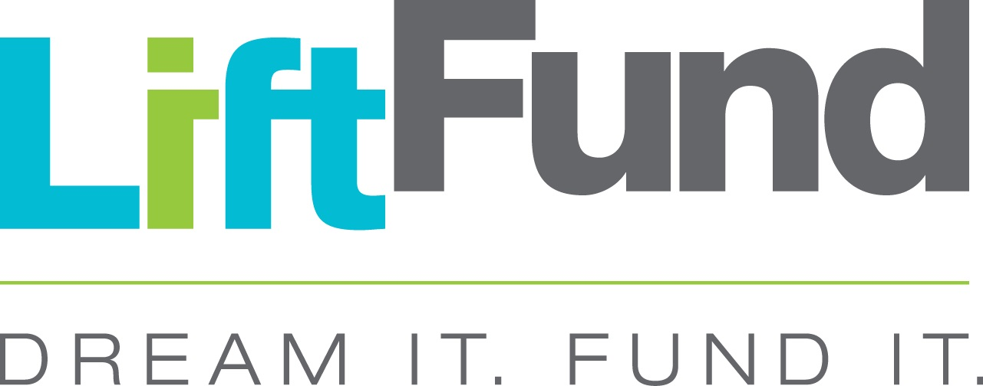

**FOR IMMEDIATE RELEASE CONTACT:**

**Nov. 13, 2019 Lisa Marie Barocas**

**(210) 438-2532**

**LMG@LMGCOMMUNICATIONS.COM**

**LiftFund hosts Quinceañera: Celebrates 15 years serving the Coastal Bend and launches new Gulf Coast Rebuild Business Loans with EDA**

**CORPUS CHRISTI, TEXAS** **– (Nov. 13, 2019) --** Nonprofit community small business lender LiftFund was pleased to celebrate its Quinceañera with a special investment in the Coastal Bend area. To continue aiding in rebuilding the Texas Gulf Coast after Hurricane Harvey, LiftFund announced it is offering an additional $3 million in loans to small businesses in the Coastal Bend area, thanks to an investment from the U.S. Department of Commerce Economic Development Administration (EDA). The loans, which have a special 4 percent interest rate now through March, will enable companies to continue rebuilding and foster economic development in the area.

In September, LiftFund received a [$3 million EDA grant](https://www.eda.gov/news/press-releases/2019/09/30/tx.htm) to establish a new Revolving Loan Fund (RLF) to assist businesses in disaster impacted areas with working capital, equipment, and inventory.

The event attracted small business community partners, community leaders and Mayor Pro Tem Rudy Garza to celebrate with LiftFund at a Quinceañera at Hester’s Café at the Art Museum, 1902 N. Shoreline Blvd. Attendees heard from Jason Rodriguez, owner of Hester’s and a LiftFund client; LiftFund President and CEO Janie Barrera; and Jorge Ayala, EDA Regional Director.

“We believe more work needs to be done in the Coastal Bend community to aid in rebuilding the Texas Gulf coast,” Barrera said. “We know business owners and entrepreneurs are resilient, and we hope our efforts will enable them to strengthen their businesses and grow the local economy.”

LiftFund has been proudly supporting small business owners since 1994 through education and mission-driven capital. In the wake of Hurricane Harvey, it was clear to LiftFund that small businesses would also need help recovering from the devastation. Community supporters stepped up to help LiftFund create a Harvey relief fund that provided interest-free loans up to $25,000. LiftFund is thankful for those donors and community partners who helped to contribute to a collective impact of some $7 million in relief capital that was loaned to 322 small businesses across impacted communities.

The additional $3 million investment from the U.S. Department of Commerce Economic Development Administration will ensure funding is available for small business owners in the area as they continue rebuilding and strengthening their businesses and communities.

For more information on LiftFund and small business funding, visit <https://www.liftfund.com/gulf-coast-business-loans>

**###**

**About LiftFund:**

LiftFund is a nonprofit small business lender that transforms lives by opening doors and leveling the financial playing field in entrepreneurship. Established in 1994, in San Antonio, Texas, LiftFund provides responsible capital and business education to small business owners and aspiring entrepreneurs. Since 2004, LiftFund has supported over 970 Corpus Christi small business owners with over $16 million in small business loans. Since its inception, LiftFund has made nearly 21,000 loans totaling more than $300 million across its 13 state footprint, which includes: Alabama, Arkansas, Florida, Georgia, Kentucky, Louisiana, Mississippi, Missouri, New Mexico, Oklahoma, South Carolina, Tennessee and Texas.

**About the U.S. Economic Development Administration (****www.eda.gov****):**

The mission of the U.S. Economic Development Administration (EDA) is to lead the federal economic development agenda by promoting competitiveness and preparing the nation's regions for growth and success in the worldwide economy. An agency within the U.S. Department of Commerce, EDA makes investments in economically distressed communities in order to create jobs for U.S. workers, promote American innovation, and accelerate long-term sustainable economic growth.