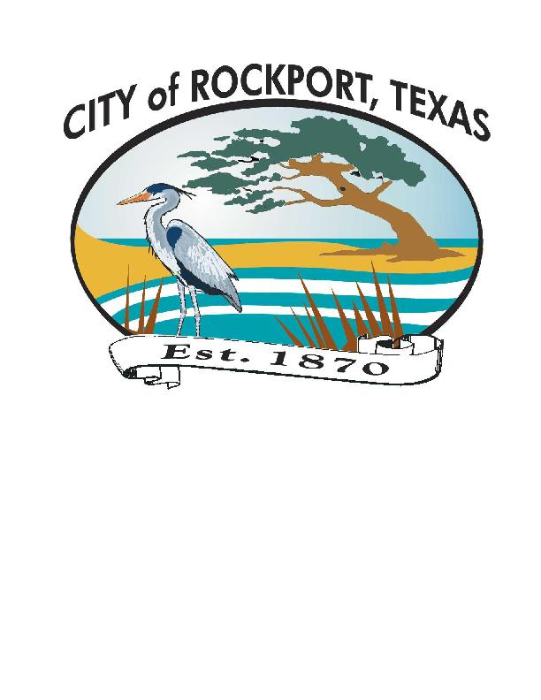
NEWS Release

City of Rockport ∙ 2751 SH 35 Bypass ∙ Rockport, Texas 78382 ∙ (361) 729-2213

For immediate release Contact: Rick Martinez or Brittany Elkins
October 16, 2019 Phone: (361) 727-2158

Free Tree Distribution for Aransas County Residents

ROCKPORT, TX –The Arbor Day Foundation, USAA and Texas A&M Forest Service, in cooperation with the City of Rockport’s Parks Department, will be giving away 750 tree saplings to Aransas County residents on Friday, October 25 from 2 – 6 pm at the Rockport Festival Grounds, located at Business 35 and Laurel Street. A similar giveaway was held last year with much success, despite severe rain, wind and cold.
November through February are the best months for planting in our area, according to Bill Green with the Texas Forest Service. The saplings to be given away, which include oak, mulberry, olive and other varieties, are suitable to grow in the coastal area.
Additionally, the organizations have donated 80, 15-gallon crape myrtle, bald cypress, burr oak and white oak trees, which will be planted by at locations throughout the City’s parks.
These efforts are part of the Foundation’s ongoing Community Tree Recovery, a national program underwritten by USAA and Foundation members, which replaces trees in communities

(more)
Free Tree Distribution – Page 2

affected by natural disasters throughout the United States. The program has held more than 800 events, distributing more than five million trees since its inception in 2012.
The City of Rockport is located on the Live Oak Peninsula, which is renowned for its iconic live oak trees and other natural resources. Having taken a direct hit from Hurricane Harvey in 2017, tens of thousands of trees were devastated, many of which provided much-needed shade and nesting sites for hundreds of local and migratory bird species. “We are extremely grateful to our partners for their generous efforts,” noted Rick Martinez, the City of Rockport’s Parks Director. “Planting and establishing trees in our community is a much- needed part of the recovery process,”
For additional information, call the City of Rockport’s Park and Leisure Services Department at (361) 727-2158 email parks3@cityofrockport.com or visit the city’s web site at www.cityofrockport.com.
-30-

