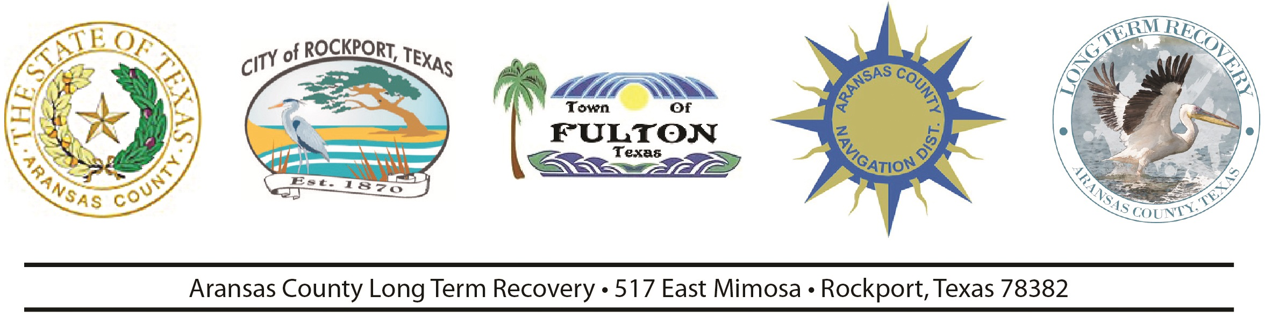
CONTACT: Deanna Spruce

Commissioners Courtroom in the Aransas County Courtroom 2840 HWY 35N Rockport Texas September 9, 2019 at 9:00 A.M.

Throughout the summer of 2019 three students worked alongside Master Naturalists and Texas Sea Grant. The three students were Liliana Cantu, Carinne Johnston, and Yvonne Sheasby. Texas Master Naturalists Kris Kirkwood, Ray Kirkwood, and Neli Spurrell provided field assistance along with Texas Sea Grant Natural Resources Specialist Morgan Ayers. The responsibilities included intensive manual removal of invasive grasses (like St. Augustine and Guineagrass) transect data collection, plant species identification, planting and protecting pollinator gardens, and protecting native plants.

We would like to recognize the following for their dedication and support of the Aransas County Pathways at Commissioners Court:
Here today: Liliana Cantu; Yvonne Sheasby; Morgan Ayers; Kris Kirkwood;
Also recognize but could not be here today: Neli Spurrell and Carinne Johnston, Ray Kirkwood

They worked all summer Monday through Thursday 7am-11am at the Aransas County Pathways. The girls have done an amazing job and worked extremely hard. We are working to have them come back next semester. We appreciate their dedication and hard work!

