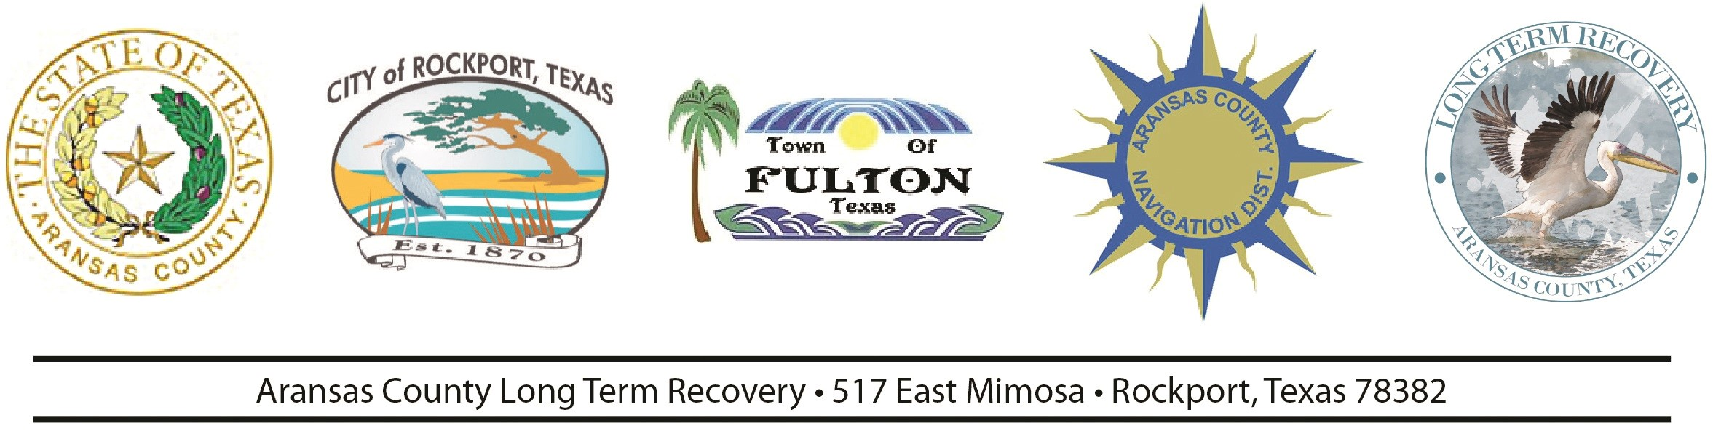

FOR IMMEDIATE RELEASE:

Contact: Deanna Spruce

[pio@aransascounty.org](mailto:pio@aransascounty.org)

**Second Harvey Anniversary Weekend filled with activities**

Aransas County residents encouraged to attend the church of their choice

(Rockport and Fulton, TX) Aransas County residents are grateful for the help and support given to them from across the nation. This second anniversary weekend will be filled with activities from groundbreakings to ribbon cuttings to a walk/run and a block party.

Local residents and visitors are encouraged to visit the church of their choice for a special message and video put together by the Long Term Recovery Public Information Officer.

Those activities include:

Aug. 23 11 am- 11:45 am **Saltgrass Landing Apartments Groundbreaking Ceremony** 1602 South Church Street.

Aug. 24 - 8 a.m. **Harvey Encore Walk/Run**. Meet at Daily Grind in Downtown Rockport. [https://forms.gle/FRcZ6gWDpaSVHyqy5](https://forms.gle/FRcZ6gWDpaSVHyqy5?fbclid=IwAR1A8KUxUJ6In_iEwvUmsgwnrO1yHVVwmqCCiqbmpFrWp_Vnm_R4zetsh7U)

Aug. 24 - 10:30 a.m. **Fulton Pier Groundbreaking Ceremony**. Meet at the site of the pier. [https://www.facebook.com/thetownoffulton/](https://www.facebook.com/thetownof.fulton/)

Aug 24 8 am **Camp Aranzazu “Camp Care Day**” Volunteers will help with light duty maintenance and landscaping projects.

Aug. 24 7:30-10:30 am St. Peter Episcopal Church (555 Enterprise Blvd) will offer breakfast celebrating our “**First Responders Breakfast.”**

Aug 25 10am **Harvey Anniversary Tree Planting Ceremony** 1601 FM 2165 (Pearl St.) [www.cityofrockport.com](http://www.cityofrockport.com)

Aug. 24 - 11 a.m. **Rockport Cultural Arts District and Rockport Little Theatre Downtown Rockport Even**t. Food trucks. Music. Children’s activities. Movie in Kids Alley at dusk <https://www.facebook.com/events/483888025489452/>

Aug. 24 - 1 p.m. - 4 p.m. **Open House and Dedication at 2 p.m. of new Hands of Hope** Building at First Baptist Church. This will be a “working” dedication and will be providing intakes in addition to Catholic Charities and Habitat for Humanity. <https://www.facebook.com/rockporthandsofhope/>

Aug. 24 - 6 p.m. - 10 p.m. **Harvey Encore Block Party** on Main Street in Downtown Rockport. Viral Rock Band. <https://www.facebook.com/events/483888025489452/>

Aug. 25 - Attend the church of your choice for a special reflection and video message. Some of the participating churches are First Baptist Church and St. Peters Episcopal Church, first United Methodist Church. Please see your church to view the video.

Aug 26 11 am **Hurricane Harvey Agency Update** FEMA TDEM General Land Office and other community leaders will provide agency updates over the past two years since Hurricane Harvey hit. The update will take place at the Public Safety Center 714 E Concho.

Help and assistance is available for those in need. Contact the Long Term Recovery office at 361-790-9496 or Facebook <https://www.facebook.com/aransascountypathwaytorecovery/>

-30-