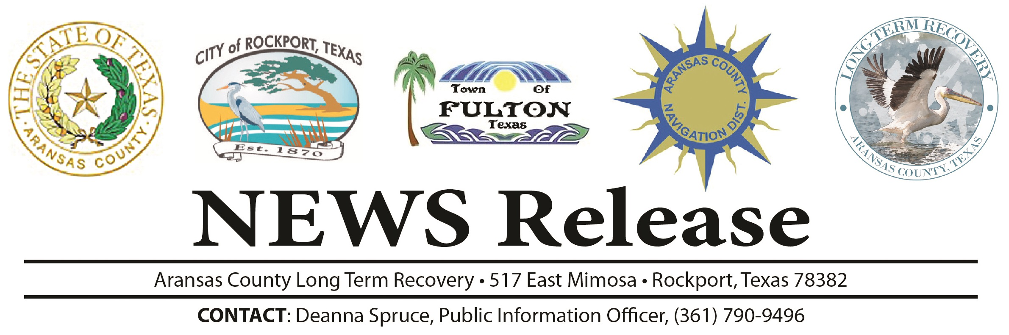

The Texas A&M Hurricane Evacuation Study Team is planning to begin distributing another round of the Hurricane Harvey evacuation surveys mailing during the week of June 17 to residents in the Coastal Bend area. In addition to providing a web-link to the online survey, this mailing will include a paper version of the survey along with a self-addressed and pre-paid postage return envelope. We encourage folks who receive this mailing to complete the survey as soon as possible to help your community and county better plan for future evacuations.

Should you receive any questions about the legitimacy of the survey, we ask for your assistance in letting folks know that this is indeed a legitimate effort on the part of FEMA, Army Corps of Engineers and State of Texas to help improve evacuation preparedness and response.

If you receive inquiries that you feel should be passed along to the study team about the survey the team can be contacted as the following email address: HarveyEvacSurvey@arch.tamu.edu

If there are other questions regarding the survey or the Hurricane Evacuation Study for the Coastal Bend, the contact information for the Texas A&M Team are listed below. Thank you for your support in this effort.

Andy Mullins, Texas A&M Transportation Institute j-mullins@tti.tamu.edu
Dr. Walter Peacock, Texas A&M Hazard Reduction and Recovery Centre peacock@tamu.edu
Dr. David Bierling, Texas A&M Hazard Reduction and Recovery Center/Texas A&M Transportation Institute d-bierling@tti.tamu.edu

