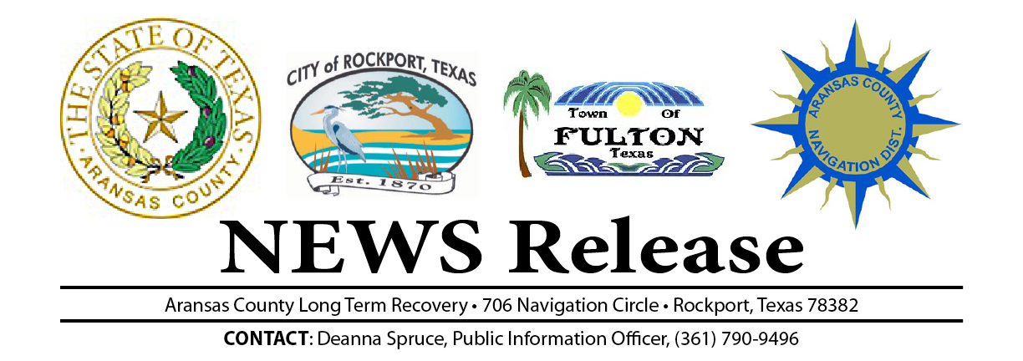
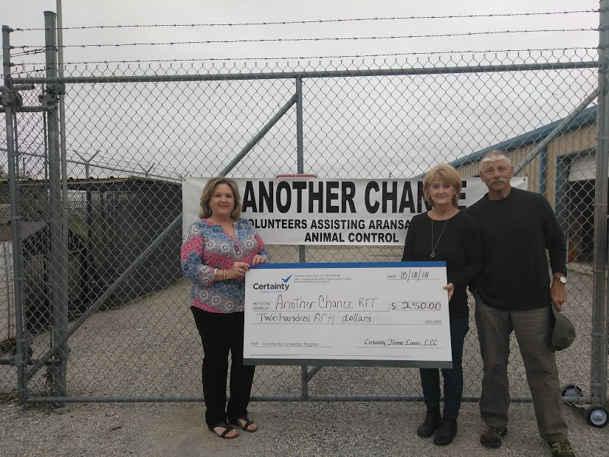
Debra Strothman with Certainty Home Loans is excited to have the opportunity to support the local non-profit organization, Another Chance RFT, through her Community Connection Program. Another Chance RFT received $250!!
Certainty Home Loans is committed to supporting the community and will donate $250, in the name of the borrower, to the borrower’s charity of choice! The donation will be made once the loan is closed and funded. All U.S. non-profit organizations that have a current 501c (3) status are eligible. A big THANK YOU goes to Susan and Paul Rezentes for choosing Another Chance RFT as your non-profit of choice and Certainty Home Loans for your mortgage needs! *In 2017, the combined support of all Certainty Home Loans branches donated $278,750 to over 160 non-profit organizations.

Another Chance RFT is a group of volunteers that assist the Aransas County Animal Control to save dogs from euthanasia.
According to Another Chance RFT Director, Tana Neel, “We vet, network with rescues and transport dogs in and out of state to permanent homes, no kill shelters and rescues. To date, we have saved 725 dogs from being put down at the Aransas County Animal Control. We do all of this on donations, small fundraisers and grants. We do NOT take any money from the county. For more information how you can assist Another Chance RFT contact Tana Neel email: tananeel@gmail.com
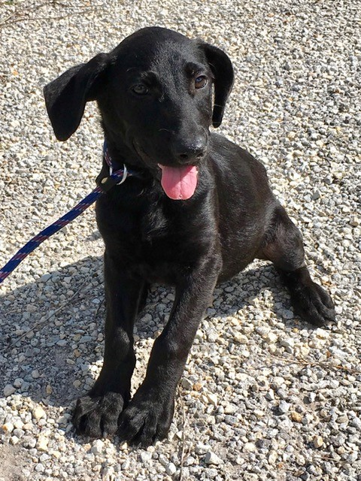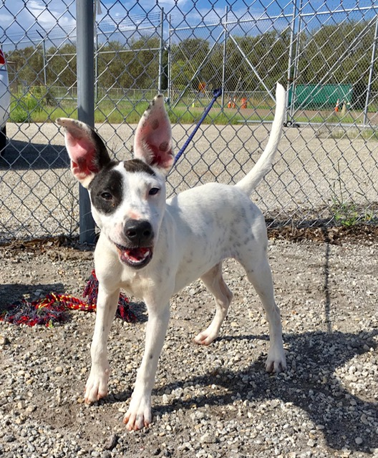

END

