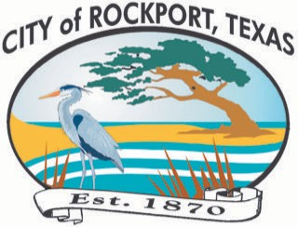 

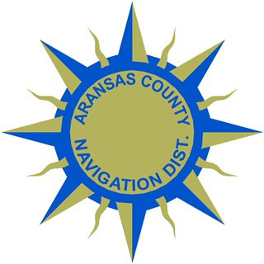 **NEWS Release**

Aransas County Long Term Recovery • 517 E. Mimosa • Rockport, Texas 78382

Contact: Deanna Spruce Phone: 361-790-9496 October 31, 2018

Aransas County long term recovery Public information officer

**removal of debris from waters in Copano Cove, Copano ridge and select portions of Salt Lake to begin Monday November 5, 2018**

ROCKPORT, TX –The removal of the last remaining amounts of hazardous debris from waters in Copano Cove and Copano Ridge and select portions of Salt Lake deposited by Hurricane Harvey will begin Monday, November 5, 2018. This includes waters that may be considered privately-owned and submerged lands. Any privately-owned facilities along the coast which require demolition are the responsibility of the owner. The limited hazardous debris removal from the privately-owned, submerged land include all canals of Copano Cove, Copano Ridge and select portions of Salt Lake.

All debris removal efforts will be conducted due to the public’s health and safety of the citizens of the impacted areas. Some specific examples of eligible items that may be found in local waters include automobiles, trucks, motorcycles and similar vehicles; sunken and submerged vessels; large appliances such as washing machines, dryers, dish-washing machines, refrigerators, hot water heaters, and similar household appliances or commercial machine items of comparable cubic dimensions; sunken, submerged, and partially collapsed structures, decks, docks, balconies, and similar man-made structures. Lone timbers or other similar small building materials are not eligible.

Aransas County will only remove storm generated hazardous debris that poses a threat to the health and safety of the public. Aransas County will not be dredging, or removing sand, silt, gravel, concrete blocks, slabs, asphalt, sidewalks, or similar items. Aransas County will not remove floating trash unless it is a barrel, drum or tank, or it is a container with a hazardous substance confirmed by the Texas Commission on Environmental Quality.

According to Judge C. H. Burt Mills, Aransas County, “We appreciate all the people that worked so diligently to state our case in front of state and federal agencies to explain why this critical step is necessary and urgently needed for our community. We are a water based community. Safe access to our water ways, and neighborhoods drives our tourism-based economy and way of life. This is an essential step in our Long-Term Recovery efforts,” Judge C.H. Burt Mills concluded.

-END-