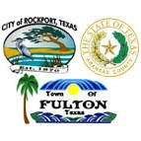

Press Release

**Burn Ban Lifted**

Judge C. H. Burt Mills lifts Burn Ban for Aransas County

"Due to the recent rain events, outdoor burning for county residents will now be allowed. However, we caution the public to use common sense when conducting outdoor burning activities,” stated Judge C. H. Burt Mills, Jr. Aransas County Judge. Lifting of the burn ban for outdoor activities does not include fireworks. Fireworks are still **not** allowed due to the continued drought conditions. For further information contact the sheriff’s office at 361-729-2222.

FOR IMMEDIATE RELEASE June 19, 2018

Contact: Deanna Spruce

Public Information Officer, Aransas County Long Term Recovery

[PIO@aransascounty.org](mailto:PIO@aransascounty.org) at 361-790-9496